Working Alone Safety Plan

Worker |  | Supervisor
Name |  | Name
Department |  | Department
Work Phone |  | Work Phone
Cell Phone |  | Cell Phone
Email |  | Email

Location and Activity Description
Address / Building and Room Location
Work Order #
(if applicable)
Activity Date(s)

Activity / Project Description

Emergency Contacts
External Emergency Services | 911
Security (All Campuses) | 250-862-5401
Security (Campus Phone) | 6699
OHS Department | 250-862-5648
Facilities Management | 250-762-5445 x4262
Hazard Assessment and Control
Activity/Task  (List all tasks and activities of the job/work) | Description of  Hazard  Note: There may be more than one hazard associated with an activity or task. | Likelihood (L) | Severity (S) | Risk Total = (L*S) | Rating (High, Moderate, Low) | Hierarchy of Hazard Controls  Elimination/Substitution (E/S) if this not an option the following hierarchy of controls is to be followed:  - Engineering Controls (EC)  - Administrative Controls (AC)  - Personal Protective Equipment (PPE) | 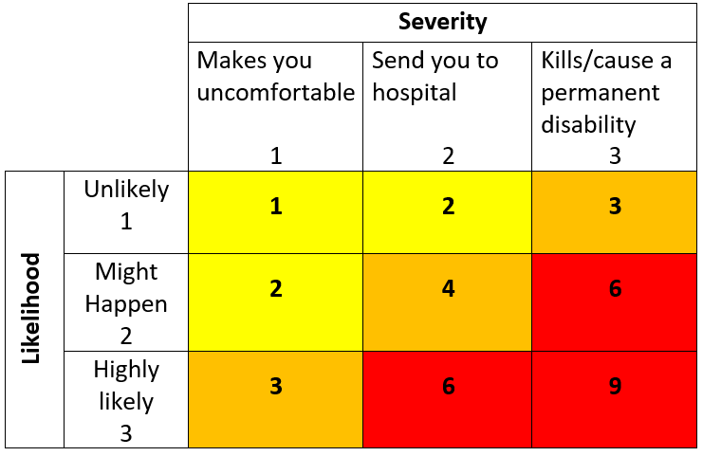  High Risk  Moderate Risk  Low Risk

Check In Procedure
Employees performing low risk work are required to check in at minimum every 4-8 hours. Employees performing medium risk work are required to check in at minimum every 2-5 hours. Employees performing high risk work should check in at minimum every 0.5-3 hours, or at a frequency that corresponds to the hazards and emergency response plans.

Check In Method: OC Safe App, Radio, Phone, Text, Email, other
Check In Schedule: Frequency and Duration (ex. Every 2 hrs. for 8-hrs)
Addition Details:

Overdue Worker Response Plan
- When an employee working alone misses a check in using the OC Safe App, the App will notify the employee’s working alone contact person (supervisor);
- The working alone contact person will attempt to contact the employee working alone by the means detailed in their Working Alone Safety Plan (radio, phone, text, etc.);
- If contact is not made within 15 minutes, the working alone contact person will arrange for face-to-face contact to be made with the overdue worker by notifying Security to dispatch a mobile unit to the employee’s location if not on campus;
- The working alone contact (supervisor) are responsible for providing details of this safety plan to emergency services as required.

Acknowledgement of Responsibilities
Supervisors are responsible to ensure: this plan is completed prior to work commencing; this plan is complied with; and details of this plan are readily available if requested by the Health and Safety Department, Security or Emergency Services.

Workers are responsible to comply with the procedures of this safety plan and the Working Alone Safety Program.

This plan accurately describes the scope of the Working Alone activity, identifies foreseeable hazards, and documents the control measures to manage the associated risks.

Supervisor Signature: | Worker Signature:
Date: | Date:
*Please submit completed plans to: OHS@okanagan.bc.ca

